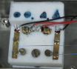

Inert gas inlet

Silver heating table,now I have the the RTD sensor on the table (picture below), it regulates the spead of heating and cooling.

Thin thermocouple „K“ for checking the temperature from the top of the sample

Flat contacts – aquadag and platinum wires

2-point method measurement

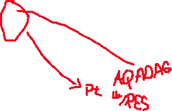

Valves for vacuum/Argon.

I do do measurement in argon.

**Nitrogen for cooling**

**RIGOL**

The vacuum pump

**I. Contacting samples with the paste:**

1. Take the dilute AQUADAG paste (already diluted – black paste in the transparent bottle) and try to mix it by shaking the bottle before using
2. Take two pieces of the platinum wires (in the glass bottle with ground-glass stopper) and try to make them as flat (straight) as possible
3. Apply the paste along one side of the sample – very thin and even layer
4. Insert the wire into the paste, this way it is along the sample covered by the aquadag
5. Repeat on the other side

**II. Vacuuming out the air**

1. Swich on the PC
2. Switch on the temperature controller at the backside - placed left side (the front press button is switched on – I position). The pump for the cooling is also all the time switched on (in case it is not, switch on at the backside of the cooling unit)
3. Switch on the cooler/chiller that is placed on the floor under the lab table (behind the pump)
4. Switch on RIGOL and EUROTHERM
5. Set the flow at the Argonne bottle max at 1 mbar(?), open the bottle with the Ar (just a little).
6. Check if the Ar flow is not blocked by any other valve
7. Open the compressed air supply for the pump
8. Start the pump (bottom-left side next to the gray cable – it facing the chiller)
9. **Place the sample on the heating plate (read I. and III.!!!)**
10. Put the lit on the heating cell and place the bolts – do not tighten yet
11. Fill-up the balloon with the argon gas
12. Open the flow of Ar into the cell (lever position is down ↓)
13. Let the Argon flow a little bit through the cell to clean it
14. Screw down the bolts
15. Stop the Ar flow at the reasonable balloon size
16. Start the pump by pressing on start
17. And then press AUTO
18. Then press „Lo-vac“ (NEVER PRESS HI-VAC)
19. The pump will start pumping
20. Open the path between the cell and the pump (lever position is up ↑)
21. Check the screws and tighten them gently
22. Let it pump to the lowest value possible and fill the cell with argon – pump again (repeat 5 times) – the final pressure is usually around 2 mbar. After last pump let the balloon filled with the argon and let the cell filled with the argon - the path between the balloon and the cell is **OPEN**. It means you can switch off the pump – 1st click on isolate chamber and then switch the pump completely, close the valve with compressed air supply.
23. Open the TK series software
24. Set the thermoprofile (you can use the excel file for automatic calculation of the ramp)
25. Press start
26. If needed – fill-up the dewar vessel with the nitrogen and place the tube with the top cover on the dewar vessel

**III. Inserting the sample onto the stage**

1. Place the sample on the silver table, mount the wires with the screws under the metal sheets 🡪 create a contact
2. Be sure that the sample is in good contact with the heating stage (bend the wires so it is not in the air)
3. Place the K thermocouple on the sample and glue it with the aquadag (somewhere to the corner of the sample which is already covered by aquadag) 🡪 very tricky process.

**IV. Use of the software**

1. When you replaced the air for the argon, start the software (the script “mysimp.vi” and the software for the heating cell “TK_series”)
2. Set the script (number of measured points – I usually put a very high number and then I just switch it of manually), the delay can be set at 500, its ok, anyway it will be delayed much more, but it is not important
3. Be careful to take out the USB Hub from the PC and put it back, otherwise it won’t be properly connected and it will show an ERROR – do it every time you start the PC
4. Set in TK-series the “INSIDE heater” (left upper corner), set the heating rate by setting the thermos-profiler – set the numbers of point for heating and for cooling as you wish (I have an excel file on the desktop that you can use for the easy calculation of number of points).
5. Then start the script, start the thermos-profiler on TK-series (one after each other at the same time) .
6. After the measurement click the right mouse button on the plot at TK-series and save the data.
7. Switch of the Mysimp script – the data are saved in blabla document – please, if you want to rename the document, you have to change the path in Mysimp script. But I leave like this and I just take out the data v from the file and save them separately in a new file.
8. You can open the matlab file mymggreadx.m – it can be a bit tricky, cause the data need to be saved in the folder “Data” and need to have the format: RT_.... .txt and T_... .txt (e.g. RT_230322.txt and T_230322.txt).
9. 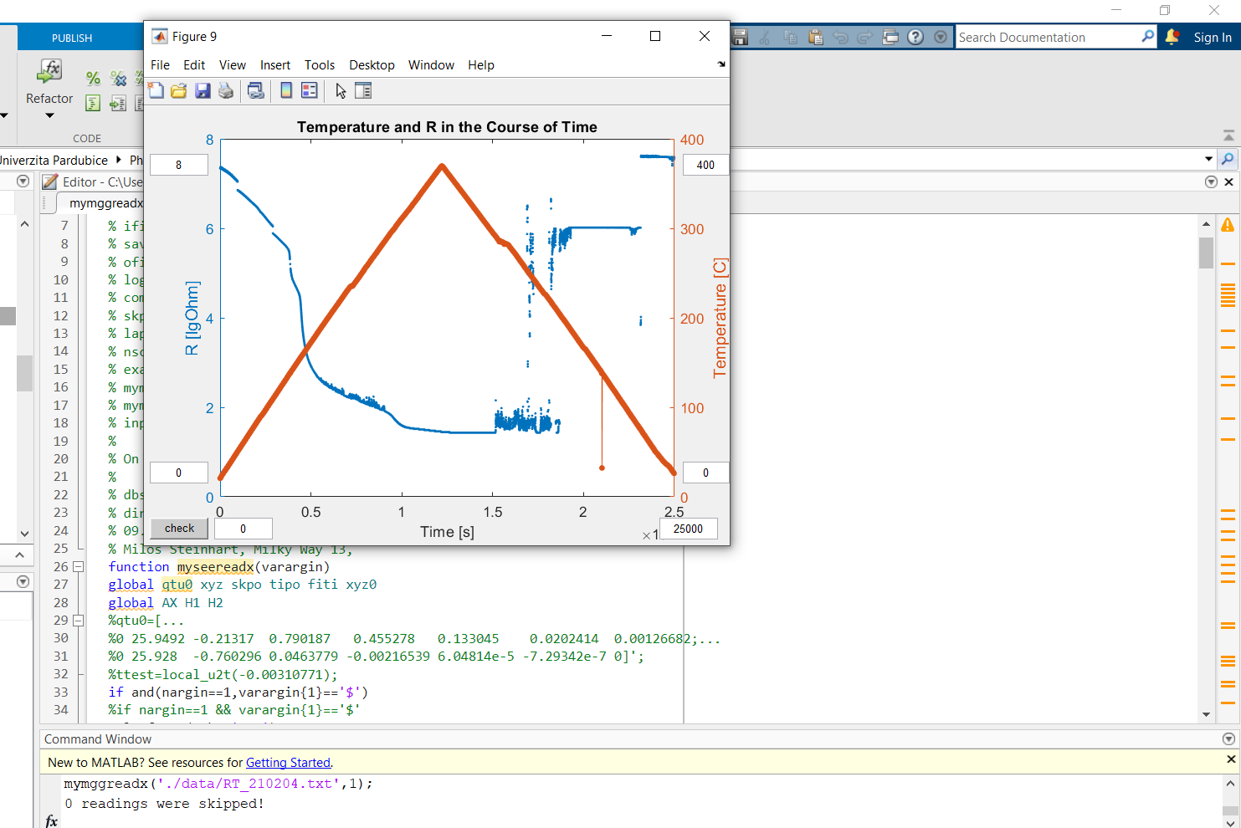
10. Write down to the Command Window this line: mymggreadx('./data/RT_210204.txt',1);
11. Then wait and it will plot 3 graphs (one it will be just the temperature from the K thermocouple, 2nd is for the temperature difference between the thermocouple K and Pt RTD and the 3rd one is a visualization of the Temperature and resistivity) and it will also create a new file called TT_.... .txt
12. The data may contain some ERRORS so then just delete them manually and sometimes, when there is a bigger difference in “starting” time between the file RT_ and file T_ it can’t plot the graphs, so be aware of this. Then you can just manually set the starting time in the files by deleting some points.

