Name:_______________________________________________ Table: _________________ Section:_________

Lab : Collisions Experiment

The Experiment
The experiment involves the following scenario, with two carts on a low friction track.

Background

The momentum of an object is its mass multiplied by its velocity. Momentum is a vector, so the direction is important.

QUESTION 1: In this experiment the motion is one-dimensional. How can you account for the direction of momentum in this case?

The kinetic energy of an object is given by KE = ½ mv². Kinetic energy is not a vector, so you don’t need to worry about direction.

QUESTION 2: In this experiment you will be determining whether momentum and kinetic energy are conserved. What does it mean for a quantity to be conserved in a collision?

One way to classify collisions is in terms of kinetic energy, as follows:
- Super-elastic, in which kinetic energy is larger after a collision.
- Elastic, in which kinetic energy is conserved.
- Inelastic, in which kinetic energy is lost.
- Completely inelastic, in which the objects stick together after the collision.
Spend a few minutes playing with the carts and the software to familiarize yourself with what can be done.

Part 1: Conservation Measurements and Calculations

For each of the three cases below, collect data and complete calculations to show the system momentum, and total system kinetic energy, before and after the collision.

Note: if you get unexpected results, call an instructor over to check what you’re doing.

Case 1: Elastic collisions. The carts have magnets in one end, which will repel one another. Make sure the magnet ends face one another. For collision 1, the masses should be equal. For collision 2, the masses should be different. Start with cart 2 at rest.

Collision | m₁ | m₂ | v_{1i} | v_{2i} | v_{1f} | v_{2f}
1 |  |  |  | 0 m/s
2 |  |  |  | 0 m/s

Collision | p_{1i} | p_{2i} | p_{i} = p_{1i} + p_{2i} | p_{1f} | p_{2f} | p_{f} = p_{1f} + p_{2f}
1 |  | 0 kg m/s
2 |  | 0 kg m/s

Collision | K_{1i} | K_{2i} | K_{i} = K_{1i} + K_{2i} | K_{1f} | K_{2f} | K_{f} = K_{1f} + K_{2f}
1 |  | 0 J
2 |  | 0 J

Case 2: Completely inelastic collisions. Turn the carts around so the Velcro ends face one another – the carts should stick together after the collision. For collision 3, the masses should be equal. For collision 4, the masses should be different. Start with cart 2 at rest.

Collision | m₁ | m₂ | v_{1i} | v_{2i} | v_{1f} | v_{2f}
3 |  |  |  | 0 m/s
4 |  |  |  | 0 m/s

Collision | p_{1i} | p_{2i} | p_{i} = p_{1i} + p_{2i} | p_{1f} | p_{2f} | p_{f} = p_{1f} + p_{2f}
3 |  | 0 kg m/s
4 |  | 0 kg m/s

Collision | K_{1i} | K_{2i} | K_{i} = K_{1i} + K_{2i} | K_{1f} | K_{2f} | K_{f} = K_{1f} + K_{2f}
3 |  | 0 J
4 |  | 0 J

Case 3: Inelastic collisions – allow the carts to touch during the collision. The Velcro end of one cart should face the magnet end of the other cart. For collision 5, the masses should be equal. For collision 6, the masses should be different. Start with cart 2 at rest.

Collision | m₁ | m₂ | v_{1i} | v_{2i} | v_{1f} | v_{2f}
5 |  |  |  | 0 m/s
6 |  |  |  | 0 m/s

Collision | p_{1i} | p_{2i} | p_{i} = p_{1i} + p_{2i} | p_{1f} | p_{2f} | p_{f} = p_{1f} + p_{2f}
5 |  | 0 kg m/s
6 |  | 0 kg m/s

Collision | K_{1i} | K_{2i} | K_{i} = K_{1i} + K_{2i} | K_{1f} | K_{2f} | K_{f} = K_{1f} + K_{2f}
5 |  | 0 J
6 |  | 0 J

Is momentum (of the system) conserved in
a. An elastic collision (Case 1)? [ ] Yes [ ] No

b. A completely inelastic collision (Case 2)? [ ] Yes [ ] No

c. An inelastic collision (Case 3)? [ ] Yes [ ] No

Explain your answers above using the data and calculations.

Is kinetic energy (of the system) conserved in

a. An elastic collision (Case 1)? [ ] Yes [ ] No

b. A completely inelastic collision (Case 2)? [ ] Yes [ ] No

c. An inelastic collision (Case 3)? [ ] Yes [ ] No

Explain your answers above using the data and calculations.

Describe and explain the differences in net kinetic energy, after the collision, between these three cases.
Name:_______________________________________________ Table: _________________ Section:_________

Part 2: Momentum bar graphs
Now, we’ll consider momentum bar graphs for three collisions. All three collisions have the same situation before the collision: a cart of mass m is moving at 2.0 m/s to the right toward a stationary cart of mass 3m. The difference between the collisions is the elasticity – one collision is elastic, the second is inelastic, and the third is completely inelastic.

Case 1 – elastic collision (elasticity is k = 1)
Here is the complete set of momentum bar graphs for collision 7. Note that any bar that is zero is shown with an x on the zero axis.

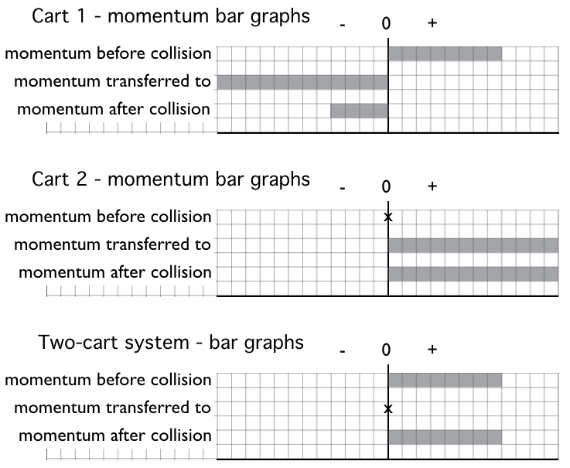

Remember that before the collision, cart 1, of mass m, is moving at 2.0 m/s to the right toward cart 2, which is not moving and has a mass 3m.

Based on the bar graphs above, what is the velocity of cart 1 after the collision?

Based on the bar graphs above, what is the velocity of cart 2 after the collision?

This is exactly the same situation, and bar graphs as the previous page – we’re just asking different questions.

Your friend Suki says “In this collision, the net momentum transferred to the system is zero. Oh, that makes sense – that’s true in all collisions.”

Is Suki right? Why or why not?

If the net momentum transferred to the system is zero, what does that imply about how the total system momentum before the collision compares to the total system momentum after the collision?

If the net momentum transferred to the system is zero, what does that imply about how the momentum transferred to cart 1 compares to the momentum transferred to cart 2?
Case 2 – inelastic collision (elasticity is k = 0.5)

Before the collision, cart 1, of mass m, is moving at 2.0 m/s to the right toward cart 2, which is not moving and has a mass 3m.

Here is an incomplete set of momentum bar graphs for collision 8. Note that any bar that is zero is shown with an x on the zero axis. Fill in the missing bars (the bars for all quantities that are underlined).

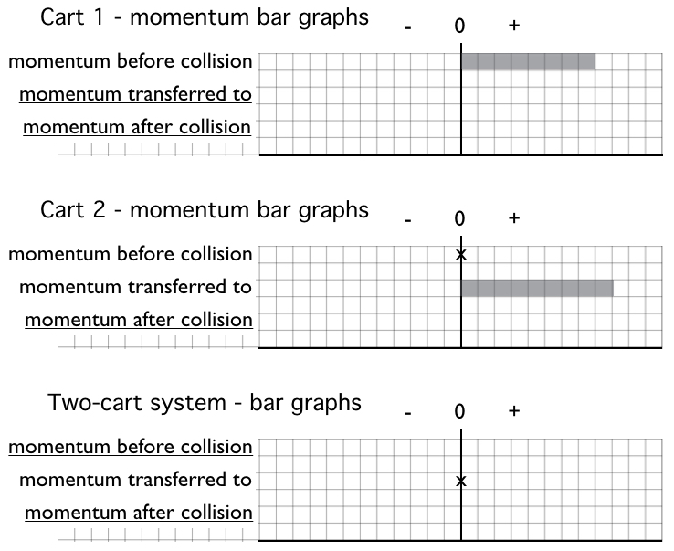

Remember that before the collision, cart 1, of mass m, is moving at 2.0 m/s to the right toward cart 2, which is not moving and has a mass 3m.

Based on the bar graphs above, what is the velocity of cart 1 after the collision?

Based on the bar graphs above, what is the velocity of cart 2 after the collision?

Case 3 – completely inelastic collision (elasticity is k = 0)

Before the collision, cart 1, of mass m, is moving at 2.0 m/s to the right toward cart 2, which is not moving and has a mass 3m.

Here is an incomplete set of momentum bar graphs for collision 9. Note that any bar that is zero is shown with an x on the zero axis. Fill in the missing bars (the bars for all quantities that are underlined).

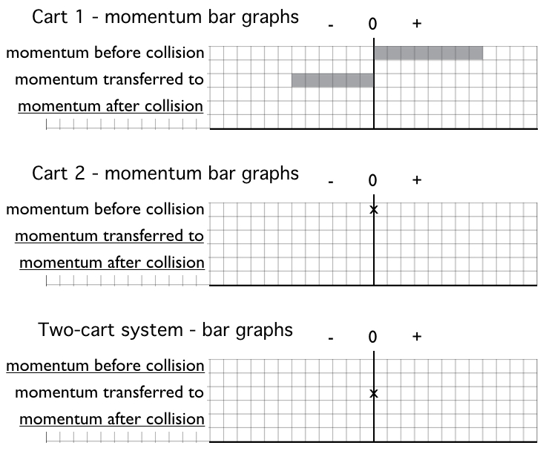

Based on the bar graphs above, what is the velocity of the carts after the collision?

Compare the three sets of bar graphs for these three types of collisions (pages 5-8). How does the momentum transfer change, going from elastic, to inelastic, to completely inelastic? We’re asking about momentum transfer for cart 1 (or cart 2), not for the system.

